Take two inputs and Subtract.

CODE

in

sto 22

in

sto 21

lda 22

sub 21

out

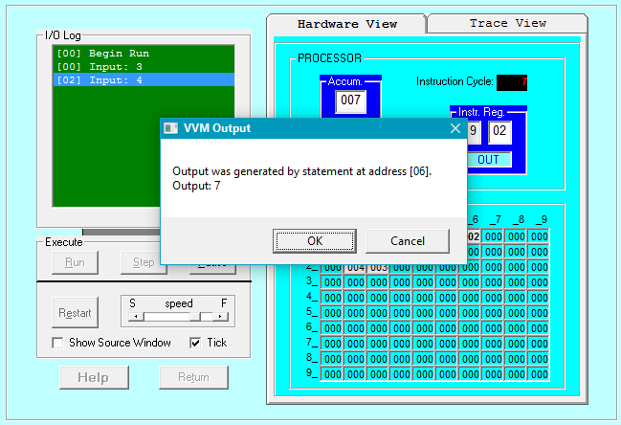

To take two hardcoded input and Add them.

in

sto 22

in

sto 21

lda 22

sub 21

out

